Español 1

Places on VHL you can go to study:
- Listening activities:
  - Under “activities” (see directions below) look for the earphone symbol to do practice. (Look for the earphone symbol in each of the chapters.)
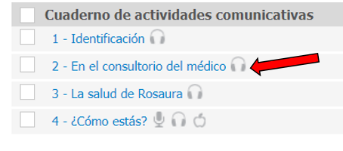
- Gramática y Vocabulario
  - Use your notes, packets, quizlet, VHL, and Profe as resources to study.
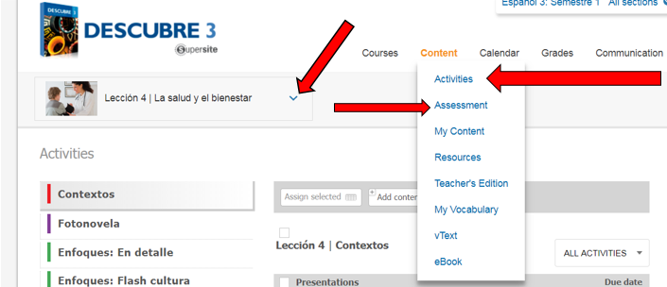
    - There are tutorials and practices exams in VHL. Go to “content”, “activities” if you want to do listening or “assessment” if you want to take practice quizzes. Make sure you also select the chapter you want on the left. There is a drop down arrow for that.

